
Quick Guide for Open License Software
Microsoft Online Services

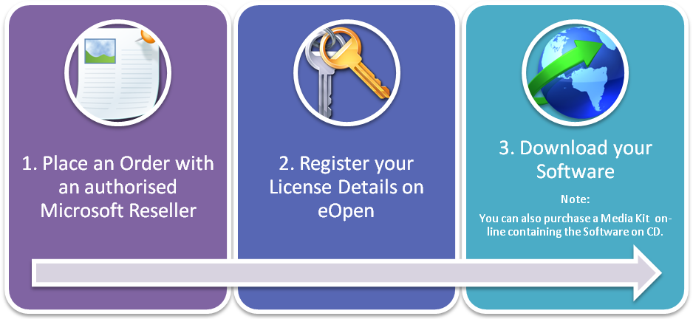
- Place an Open License Order with a Volume Licensing Reseller. For more information on the Open License program, visit http://www.microsoft.com/licensing/programs/open.

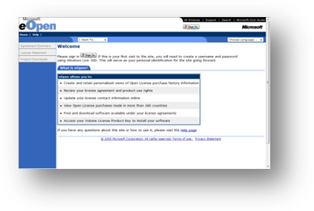
- Register your License Details on eOpen. You will receive an Authorisation and a License Number on your Order Confirmation which is published via email direct from Microsoft (It is important that you provide your email alias on the Open License order) or received via your Reseller. Use these details to register your License on https://eopen.microsoft.com.
A Windows Live ID (formerly Passport ID) is required for authentication to the eOpen website. You can use an existing Windows Live ID or create a new one at http://get.live.com/getlive/overview/.

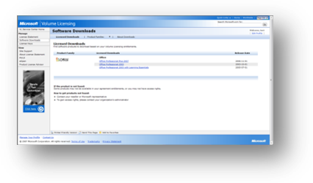
- Download your Software. Once you have signed your Open License Agreement, you have access to the Product Downloads section on the Volume Licensing Service Centre (VLSC).
This allows you to download software products based on your Volume Licensing entitlements:
- Upgrade to new software
- Quickly view all your downloads

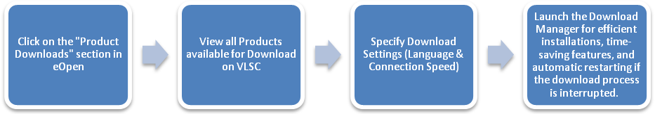

Questions?
I prefer to get a CD than downloading the software. Where can I order one?
You can purchase a Media Kit through the Product Downloads page.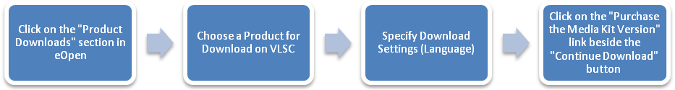
What is the delivery time for software products?
The download option allows you to quickly access the software products you are entitled to as per your Open License Agreement.
If you have purchased a Media Kit, contact the Support Centre within 14 days if you have not received the software product.
I don’t see a product that I ordered on the Product Downloads page.
There could be two reasons why you do not see the product:
- Your order is still in processing. Your authorised Microsoft Reseller will provide you with an Order Confirmation once the order is fully processed.
- This product is not available as a download. You will be able to purchase a Media Kit in this case through the Support Center. The media will be shipped free of charge for those products that are not available for download.
Who can I contact if I have any questions or issues?
For any issues with Open License registration, downloading software or ordering a media kit, you can contact the Support Centre (see contact details on the next page).
Links
- eOpen: https://eopen.microsoft.com
- Open License Program Information: http://www.microsoft.com/licensing/programs/open/
- Product Activation Information: http://www.microsoft.com/licensing/resources/vol/
- Software Assurance Information: http://www.microsoft.com/licensing/sa/

Updated: March 2008

© 2008 Microsoft Corporation. All rights reserved.
Microsoft is a registered trademark of Microsoft Corporation in the United States and/or other countries. Microsoft makes no warranties, express or implied, in this document. This information is provided to help guide your authorized use of products you license; it is not your agreement/enrollment. Your use of products licensed under your volume license agreement/enrollment is governed by the terms and conditions of that agreement/enrollment. In the case of any conflict between this information and your agreement/enrollment, the terms and conditions of your agreement/enrollment control. Prices for licenses acquired through Microsoft resellers are determined by the reseller.

